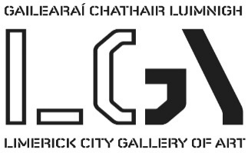

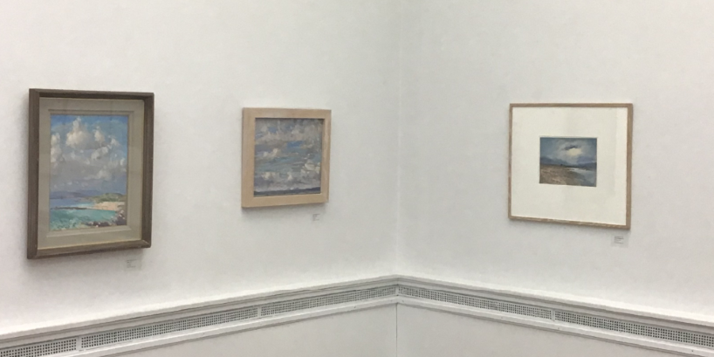

Selected works from the Permanent Collection.
January – April 2019

This selection is based on the ‘sky line’ of clouds and light in our skies. By Artist who interpret the light in the sky, clouds and land and seascapes. The works date from the 18th century to present day.

There are over 40 artworks in this exhibit featuring some of our favourite works by artists like Walter Verling, Paul Henry, Jack B. Yeats, Eva & Letita Hamilton, John Shinnors, Donald Teskey, Charles Lamb and many more.

We hope you enjoy the exhibition.

Further queries to artgallery@limerick.ie

Every effort has been made to ensure that the information provided on the Limerick City Gallery of Art website is accurate and up-to-date. If you notice any errors or omissions please let us know as soon as possible and we will correct them

Carnegie Building, Pery Square, Limerick, Ireland. FREE ADMISSION
Tel: +353(0)61 310633; F:+353(0)61 310228; Email: artgallery@limerick.ie; Web www.gallery.limerick.ie
Opening Hours: Monday/Tuesday/Wednesday/Friday & Saturday 10-5.30pm; Thursday 10-8pm; Sunday 12-5.30.
LAST ENTRY 5 & 7.30pm Closed on Public & Bank Holidays.

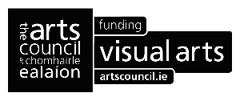

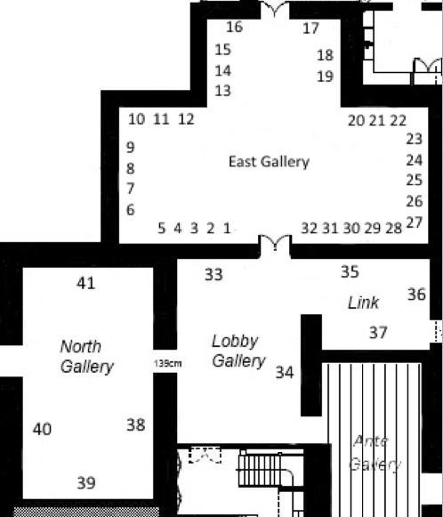
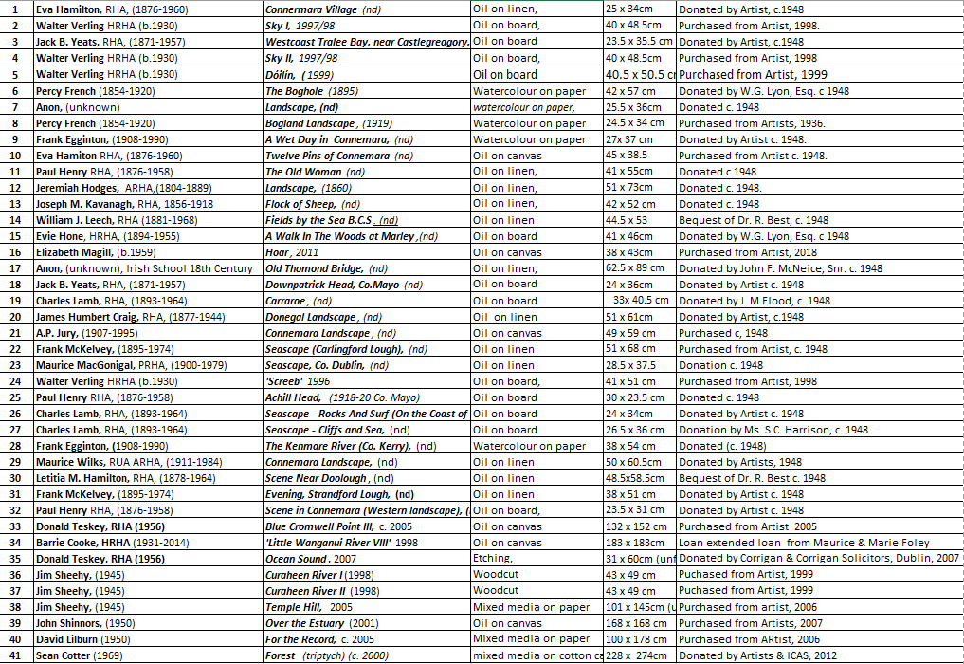

Walter Verling HRHA (b.1930) is an influential and highly respected painter who has been engaged in landscape painting since his youth and has remained committed to "plein air". His greatest influence was Charles Lamb the Connemara painter with whom he painted in the 1960's, he later befriended Cormac Mehegan, painter and noted designer, with whom he has painted for the past 40 years.
Born in New Ross, Co Wexford in 1930, he has strong Limerick connections. Sixty Year Retrospective an extensive exhibition of over 120 outstanding works in painting and drawing made from the 1940's to 2008 was presented in Limerick City Gallery of Art in Summer 08, celebrated Verling's unique contribution to Irish Art. The hardback catalogue included an essay by The Irish Times Chief Art Critic Aidan Dunne, placing Verling within the social history of Munster and in the Irish and European Art scenes of the 50's through to the 21st century.
He taught and influenced generations of Irish school teachers at Mary Immaculate College, all the while maintaining a strong painting career. Verling was awarded membership of Honorary Council of the Royal Hibernian Academy (HRHA) in 1994
******************
Charles Lamb, RHA, (1893-1964) was born in Portadown, Co. Armagh and worked as a house painter before teaching art and painting professionally. Studying first at the local Technical School, he took evening classes at the Belfast School of Art until he was granted a scholarship to Dublin’s Metropolitan School of Art. He had a deep affinity for the West of Ireland, travelling around the area painting and living for many years in Carraroe, Co. Galway where he ran a summer painting school.

Lamb became a member of the RHA and RUA exhibiting widely throughout Ireland and America, including at the Olympic Art Exhibition in Los Angeles (1932). A memorial show was held in his honour in 1969 in the Municipal Gallery of Modern Art and many of his works are held in Irish public museums.
******************
James Humbert Craig (1877-1944) was a landscape painter born in Belfast. He enrolled at the Belfast School of Art but failed to finish even one term, therefore, he was largely a self-taught artist. His passion for the outdoors and landscape meant that the Glens of Antrim, Donegal and Connemara were his most popular areas for painting. At one stage he did immigrate to the US but only stayed for a short time before returning to Co. Down.
James’ works first appeared in the RHA in 1915 and he continued to contribute his art here until he died. In 1928, Humbert Craig was elected to the Royal Ulster Academy and the Royal Hibernian Academy. Additionally, he exhibited his work at the Fine Arts Society in London and was an academician of the Ulster Academy of Arts. Through his paintings we can see that he had a simple golden rule, which was to ‘never try to improve on nature’. In 1923, an article in ‘The Studio’ said, ‘In the North the best men are, almost without exception, engrossed in landscape. They form a very distinct group whose work is characterised by typical racial traits. Their landscapes, though by no means emotional, are always most obviously sincere, closely observed, firmly and cleanly handled….’. This is of course referring to Craig.
Craig worked right up to his death in 1944 and a memorial exhibition was held in the Belfast Museum and Art Gallery. His work continues to be widely reproduced through the likes of posters and calendars and he has many followers due to his style of capturing the subject.
******************
William J. Leech (1881-1968) was a Dublin born artist who studied at the Metropolitan School before transferring to the Royal Hibernian Academy under Walter Osborne. In 1903 he travelled to Paris where he became fascinated with the Brittany coastline and countryside, painting extensively before returning to England. Taking influence from impressionism, his paintings and illustrations featured coastal and harbour scenes, landscapes, interiors, still life and portraits.
Leech became friendly with fellow artists George Russell, Constance Gore-Booth and Casimir Dunin Markievicz, holding several group exhibitions with them and others, including William Orpen and Jack Yeats at the first Aonach Art Exhibition, organised by Sinn Féin.

Frank McKelvey, RHA RUA (1895-1974) was a landscape and portrait painter born in Belfast. Before entering the Belfast School of Art he was a poster designer with David Allen & Sons. McKelvey won the Sir Charles Brett prize (1912) and the Fitzpatrick prize for figure drawing in 1914 and in 1917; he won a bronze medal in the Taylor Art competition.
In the early stages of his career, Frank was commissioned by Thomas McGowan to produce pictures of Old Belfast. Once he had completed the task, the pictures were later shown in 1930 in the Ulster Museum. This gained Frank huge recognition and from 1918 to 1973, he showed pictures in the Royal Hibernian Academy without missing a year. In 1930 he became a full member of the RHA and was one of the first Academicians of the Royal Ulster Academy. In 1936, Dutch citizens in Ireland as a gift for Princess Juliana purchased a few of his landscapes.
S.B Kennedy wrote a book called, ‘Frank McKelvey, RHA RUA, 1993’ and in it he wrote, ‘In essence he was a Romantic; yet in the inter-war years in particular, with his contemporaries amongst the landscapists, he helped to forge a new and distinct way of representing the Irish scene which is the nearest approximation we have to a distinct Irish school of painting….He had a sharp eye and could, with apparent ease, penetrate the essentials of his subject and set it down with a matching exactitude.’

******************

Anne Primrose Jury HRUA, (1907-1995) was an animal, flower and landscape painter born in Co. Antrim. Her father encouraged her career as he was a watercolourist and so she went on to study at the Belfast School of Art and then in England, France and Switzerland.
Anne exhibited her work for the first time in the Royal Hibernian Academy in 1929. The first piece of work she sold was at the RHA. Most of her landscapes appeared to be of Co Antrim and Co Down. She was appointed an associate of the Ulster Academy of Arts in 1933; forty years later in 1976 she became an academician.
In 1936, Jury began to receive an increased appreciation for her flower paintings. The Belfast News Letter said, ‘Miss Jury’s paintings of flowers are on as high a plane as one will find in Irish art to-day.’ Jury worked all of her life for the Ulster Society for the Prevention of Cruelty to Animals which is where she was inspired to paint donkeys. She died in hospital in 1995 and so a sale of her works took place in her studio later on that year which in turn aided the USPCA immensely.

******************

